Title in English (Times New Roman; size-13; Interline 1)
العـنـوان باللغة العربية (الخط: Sakkal Majalla، الحجم 15، التباعد بين الأسطر 1)
Full name of the first author ¹, Full name of the second author ²
¹ Full affiliation (Country), laboratory affiliation, professional e-mail of the first researcher,
²Full Full affiliation (Country), laboratory affiliation, professional e-mail of the second researcher,
Received: .../…/2023 | Accepted: .../…/2023 | Published: ../../2023
Abstract: (Not more than 150 Max – One Bloc)
Enter your abstract here (an abstract is a brief, comprehensive summary of the contents of the article). Enter your abstract here (an abstract is a brief, complete summary of the contents of the article). Enter your abstract here (an abstract is a brief, complete summary of the contents of the article). Enter your abstract here (an abstract is a brief, comprehensive summary of the contents of the article). Enter your abstract here (an abstract is a brief, complete summary of the contents of the article).
Keywords: keywords; keywords; keywords; keywords; keywords.
ملخص: ) 150 كلمة على الأكثر)
ضع الملخص هنا (يتم الإشارة في الملخص إلى هدف البحث، والنتائج المتوصل إليها في فقرتين). ضع الملخص هنا (يتم الإشارة في الملخص إلى هدف البحث، والنتائج المتوصل إليها في فقرتين). ضع الملخص هنا (يتم الإشارة في الملخص إلى هدف البحث، والنتائج المتوصل إليها في فقرتين). ضع الملخص هنا (يتم الإشارة في الملخص إلى هدف البحث، والنتائج المتوصل إليها في فقرتين).
كلمات مفتاحية: ك. م1.، ك. م2.، ك. م3.، ك. م4.، ك. م5.

1. INTRODUCTION
The introduction of the paper should consist of a related preface of the main research topic, the research problem, the research hypothesis and the research study strategy. The introduction of the paper should consist of a related preface of the main research topic, the research problem, the research hypothesis and the research study strategy. The introduction of the paper should consist of a related preface of the main research topic, the research problem, the research hypothesis and the research study strategy
2. Title
2.1 First Subtitle
Enter here the text of the first subtitle, enter here the text of the first subtitle, enter here the text of the first subtitle, enter here the text of first subtitle, enter here the text of the first subtitle, enter here the text of the first subtitle, Enter here the text of first subtitle.
2.2 Second Subtitle
Enter here the text of the second subtitle, enter here the text of the second subtitle, enter here the text of the second subtitle, enter here the text of the second subtitle, enter here the text of the second subtitle, enter here the text of second subtitle, enter here the text of second subtitle.
3. Title
3.1 First Subtitle
Enter here the text of the first subtitle, enter here the text of the first subtitle, enter here the text of the first subtitle, enter here the text of the first subtitle, enter here the text of the first subtitle, enter here the text of the first subtitle, Enter here the text of first subtitle.
3.2 Second Subtitle
Enter here the text of the second subtitle, enter here the text of the second subtitle, enter here the text of the second subtitle, enter here the text of the second subtitle,

Table 1. Table title (this is an example of table 1)
Results  Test | Results 1 | Results 2 | Results 3
Test 1 | 15.21 | 15.21 | 15.21
Test 2 | 18.58 | 18.58 | 18.58
Test 3 | 11.14 | 11.14 | 11.14
Source: (author’s name, year, page) (Adopt style: (APA) automatically)

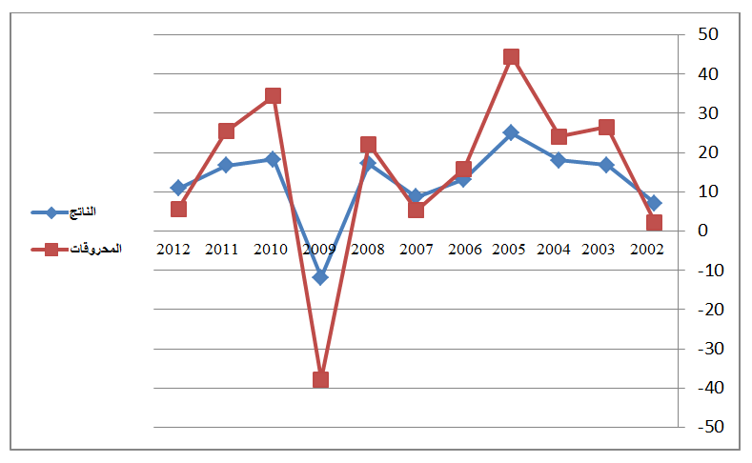
Fig.1. Figure title (this is an example of figure 1)
Source: (author’s name, year, page) (Adopt style: (APA) automatically)

4. CONCLUSION
The conclusion of a research paper needs to summarise the content and purpose of the article. The conclusion of a research paper needs to summarise the content and purpose of the article. The conclusion of a research paper needs to summarise the content and purpose of the article. The conclusion of a research paper needs to summarise the content and purpose of the article. The conclusion of a research paper needs to summarise the content and purpose of the article. The conclusion of a research paper needs to summarise the content and purpose of the article.

5. Bibliography List:
Use the « APA Reference System ». See the link :

https://www.youtube.com/watch?v=AmiKblUQs_A

The references must be directly quoted in the body of the text (e.g.: ... (Brown, 2006, p35), without overlooking to mention the complete reference in the list of references at the end of the paper, written in the following manner:
- Books: author’s name (year), full title, publishing, country;
- Theses: researcher (year), thesis title, college, university, country;
- Journal article: author’s name (year), full title of the article, review name, place, volume and number, page;
- Seminar article: author’s name (year), full title of the paper, title of seminar, place and date, country;
- Internet websites: author’s name (year), full title of the file, detailed web site: http://fulladdress (consulted on day/month/year).

6. Appendices

(Note: the number of pages must not exceed 20 pages and no less than 15 pages)

Corresponding author

